COVID19 Data Analysis from Google Open Data using Hive, Pig, and Tableau
Authors: Andrew Rosalino; Andrew Tran; Edgar Manukian; Thomas Lew; Brian Sangalang
Instructor: Jongwook Woo

Objectives
- Upload data and analyze via wget
- Create a table and test data via Hive
- Clean and test data via Pig
- Store and Export data into Hadoop then Local Machine
- Visualizations and Analysis using PowerBI

Platform Specifications
- Hostname: bigdaiun0.sub03291929060.trainingvcn.oraclevcn.com
- OS: Oracle Linux Server 7.9
- Storage: 120 GB
- Memory Size: 32 GB
- CPU: AMC EPYX 7J13 64-Core Processor @ 2.45 Ghz
- Cluster Version: Hadoop 3.1.2
- Cluster Number of Nodes: 3

Prerequisites
- Operating Systems
  - Windows 10 or 11
  - MacOS
  - Linux
- Shell terminal
  - For windows, download and install Git Bash: https://git-scm.com/downloads
  - On Linux or Mac computer, use terminal
- Microsoft Excel
- Microsoft PowerBI
- OpenRefine

Step 1: Download datasets from Google Covid-19 Open Data
Go to https://health.google.com/covid-19/open-data/
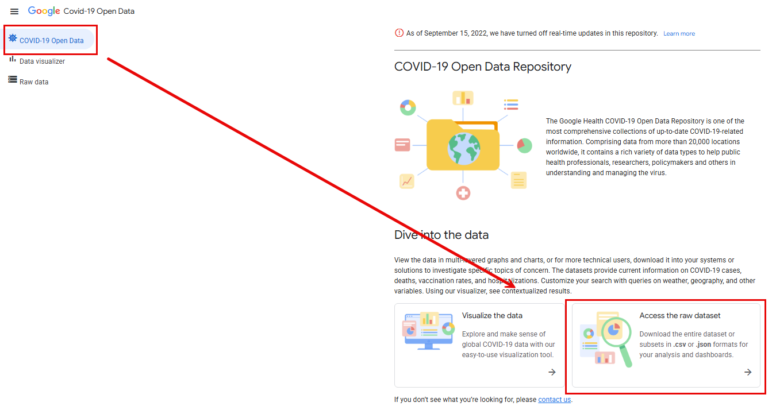
Download the csv files of the following tables:
- Index
- Demographics
- Epidemiology
- Geography
- Health
- Hospitalizations
- Vaccinations
- By age
- By sex
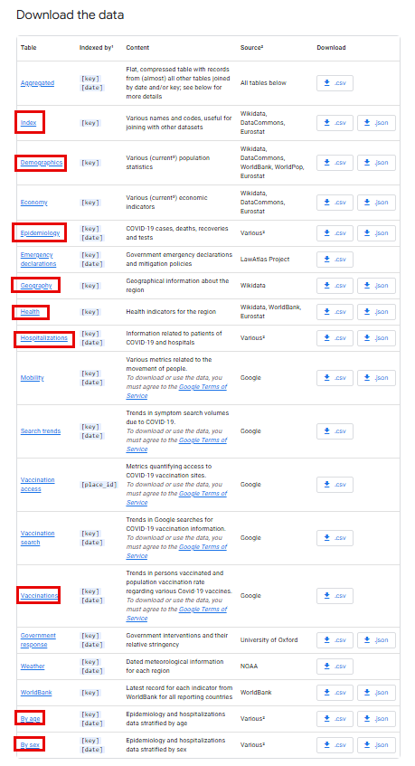
Clean tables using OpenRefine.
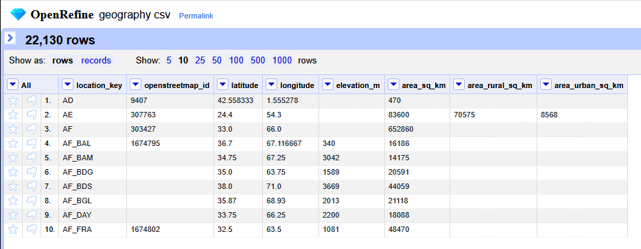
Selected the fields I want to drop
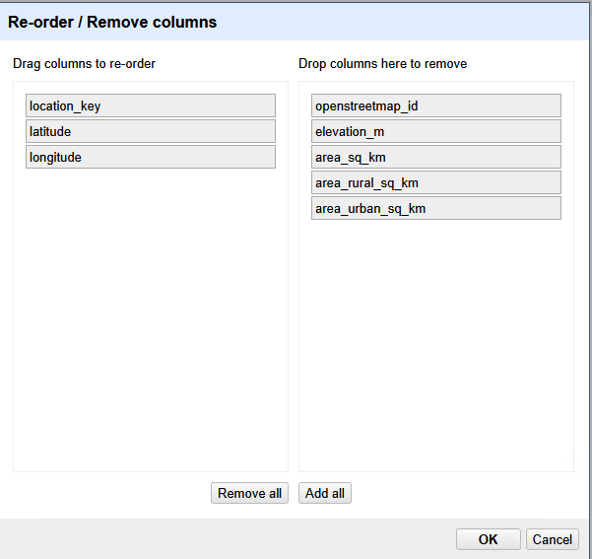
Export the file into a csv.
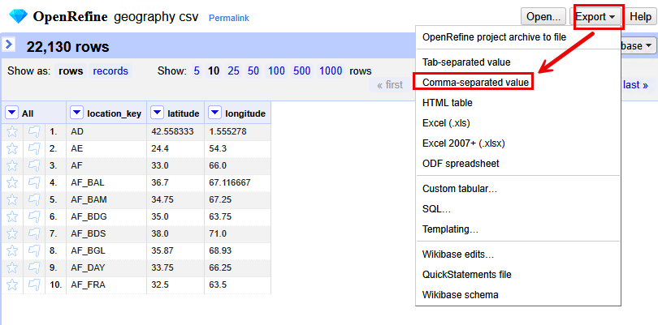
Do this with all the csv files
Step 2: Load Data in Oracle Linux Server
Open Git Bash terminal on your local computer

In the shell terminal, use ssh to connect to the Oracle cluster
ssh username@ip

-- covid19 tables data loaded into oracle big data server
wget https://github.com/chica-94/COVID19-Data-Analysis/raw/refs/heads/main/covid19_tables.zip
ls -lha covid19_tables.zip
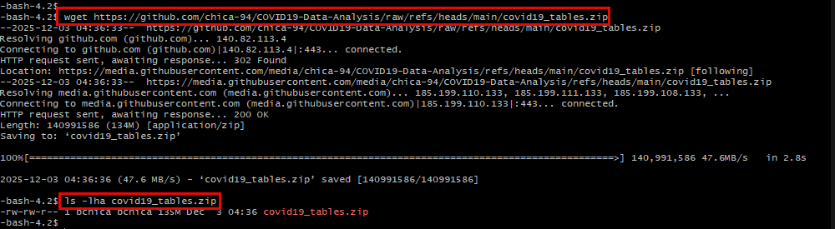

Extract dataset
unzip covid19_tables.zip
ls -lha covid19_tables
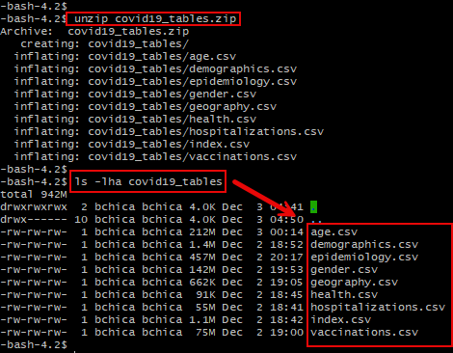
Step 5: Upload datasets to HDFS
Create a directory rating to put the filse to HDFS. Then upload the covid data to the new directory in HDFS. Once the file is added, verify all file is uploaded to covid19 directory (table):

cd covid19_tables

hdfs dfs -mkdir tmp/group3_covid19/index
hdfs dfs -mkdir tmp/group3_covid19/hospitalizations
hdfs dfs -mkdir tmp/group3_covid19/health
hdfs dfs -mkdir tmp/group3_covid19/vaccinations
hdfs dfs -mkdir tmp/group3_covid19/demographics
hdfs dfs -mkdir tmp/group3_covid19/geography
hdfs dfs -mkdir tmp/group3_covid19/gender
hdfs dfs -mkdir tmp/group3_covid19/epidemiology
hdfs dfs -mkdir tmp/group3_covid19/age
hdfs dfs -mkdir tmp/group3_covid19/gender
hdfs dfs -mkdir /tmp/group3_covid19/agggregated
hdfs dfs -mkdir /tmp/group3_covid19/top10_countries/

hdfs dfs -ls tmp/group3_covid19/
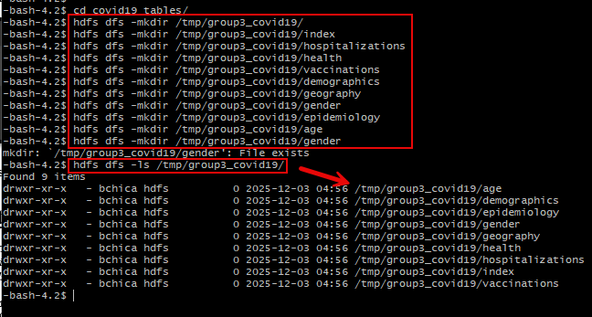

Upload the covid19 datasets into the their respective directories in HDFS. Once the file is added, verify all files are uploaded to covid19 directory (table):

hdfs dfs -put index.csv tmp/group3_covid19/index
hdfs dfs -put hospitalizations.csv tmp/group3_covid19/hospitalizations
hdfs dfs -put health.csv tmp/group3_covid19/health
hdfs dfs -put vaccinations.csv tmp/group3_covid19/vaccinations
hdfs dfs -put demographics.csv tmp/group3_covid19/demographics
hdfs dfs -put geography.csv tmp/group3_covid19/geography
hdfs dfs -put gender.csv tmp/group3_covid19/gender
hdfs dfs -put epidemiology.csv tmp/group3_covid19/epidemiology
hdfs dfs -put age.csv tmp/group3_covid19/age

Ensure that all files loaded to hdfs and are in their designated directories
hdfs dfs -ls -R tmp/group3_covid19/
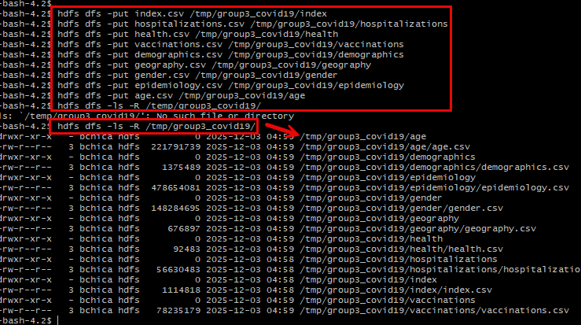
Step 6: Create Tables Using Beeline
Now that the data is loaded in HDFS, we can now use Hive to create a table and query the data using hiveql commands
Open the Hive shell environment using beeline.
beeline
Use your database to create tables
use bchica;
Paste the following HiveQL code to create an external table called which will contain all the data from each dataset uploaded to HDFS. We start by applying a “DROP” command to remove any existing table that may come into conflict

Create covid19_index table
DROP TABLE IF EXISTS covid19_index;

CREATE EXTERNAL TABLE IF NOT EXISTS covid19_index(
location_key STRING,
country_code STRING,
country_name STRING,
subregion1_name STRING,
subregion2_name STRING)
ROW FORMAT DELIMITED FIELDS TERMINATED BY ','
STORED AS TEXTFILE LOCATION '/tmp/group3_covid19/index/'
TBLPROPERTIES ("skip.header.line.count"="1");

Create covid19_hospitalizations table
DROP TABLE IF EXISTS covid19_hospitalizations;

CREATE EXTERNAL TABLE IF NOT EXISTS covid19_hospitalizations(
event_date DATE,
location_key STRING,
new_hospitalized_patients INT,
cumulative_hospitalized_patients INT,
new_intensive_care_patients INT,
cumulative_intensive_care_patients INT)
ROW FORMAT DELIMITED FIELDS TERMINATED BY ','ROW FORMAT DELIMITED FIELDS TERMINATED BY ','
STORED AS TEXTFILE LOCATION '/tmp/group3_covid19/hospitalizations/'
TBLPROPERTIES ("skip.header.line.count"="1");

Create covid19_health table
DROP TABLE IF EXISTS covid19_health;

CREATE EXTERNAL TABLE IF NOT EXISTS covid19_health(
location_key STRING,
adult_male_mortality_rate DOUBLE,
adult_female_mortality_rate DOUBLE,
life_expectancy DOUBLE,
diabetes_prevalence DOUBLE,
health_expenditure_usd DOUBLE,
out_of_pocket_health_expenditure_usd DOUBLE)
ROW FORMAT DELIMITED FIELDS TERMINATED BY ','
STORED AS TEXTFILE LOCATION '/tmp/group3_covid19/health/'
TBLPROPERTIES ("skip.header.line.count"="1");

Create covid19_vaccinations table
DROP TABLE IF EXISTS covid19_vaccinations;

CREATE EXTERNAL TABLE IF NOT EXISTS covid19_vaccinations(
event_date DATE,
location_key STRING,
new_persons_fully_vaccinated INT,
cumulative_persons_fully_vaccinated INT)
ROW FORMAT DELIMITED FIELDS TERMINATED BY ','
STORED AS TEXTFILE LOCATION '/tmp/group3_covid19/vaccinations/'
TBLPROPERTIES ("skip.header.line.count"="1");

Create covid19_geography table
DROP TABLE IF EXISTS covid19_geography;

CREATE EXTERNAL TABLE IF NOT EXISTS covid19_geography(
location_key STRING,
latitude DOUBLE,
longitude DOUBLE )
ROW FORMAT DELIMITED FIELDS TERMINATED BY ','
STORED AS TEXTFILE LOCATION '/tmp/group3_covid19/geography/'
TBLPROPERTIES ("skip.header.line.count"="1");

Create covid19_demographics table
DROP TABLE IF EXISTS covid19_demographics;

CREATE EXTERNAL TABLE IF NOT EXISTS covid19_demographics(
location_key STRING,
population INT,
population_male INT,
population_female INT,
population_age_00_09 INT,
population_age_10_19 INT,
population_age_20_29 INT,
population_age_30_39 INT,
population_age_40_49 INT,
population_age_50_59 INT,
population_age_60_69 INT,
population_age_70_79 INT,
population_age_80_and_older INT )
ROW FORMAT DELIMITED FIELDS TERMINATED BY ','
STORED AS TEXTFILE LOCATION '/tmp/group3_covid19/demographics/'
TBLPROPERTIES ("skip.header.line.count"="1");

Create covid19_gender table
DROP TABLE IF EXISTS covid19_gender;

CREATE EXTERNAL TABLE IF NOT EXISTS covid19_gender(
`date1 DATE,
location_key STRING,
new_deceased_male INT,
cumulative_deceased_male INT,
new_deceased_female INT,
cumulative_deceased_female INT,
new_recovered_male INT,
cumulative_recovered_male INT,
new_recovered_female INT,
cumulative_recovered_female INT)
ROW FORMAT DELIMITED FIELDS TERMINATED BY ','
STORED AS TEXTFILE LOCATION '/tmp/group3_covid19/gender/'
TBLPROPERTIES ("skip.header.line.count"="1");

Create covid19_epidemiology table
DROP TABLE IF EXISTS covid19_epidemiology;

CREATE EXTERNAL TABLE IF NOT EXISTS covid19_epidemiology(
`date1 DATE,
location_key STRING,
new_confirmed INT,
cumulative_confirmed INT,
new_deceased INT,
cumulative_deceased INT,
new_recovered INT,
cumulative_recovered INT)
ROW FORMAT DELIMITED FIELDS TERMINATED BY ','
STORED AS TEXTFILE LOCATION '/tmp/group3_covid19/epidemiology/'
TBLPROPERTIES ("skip.header.line.count"="1");

Create covid19_age table
DROP TABLE IF EXISTS covid19_age;

CREATE EXTERNAL TABLE IF NOT EXISTS covid19_age(
event_date DATE,
location_key STRING,
new_recovered_age_0-9 INT,
new_recovered_age_10-19 INT,
new_recovered_age_20-29 INT,
new_recovered_age_30-39 INT,
new_recovered_age_40-49 INT,
new_recovered_age_50-59 INT,
new_recovered_age_60-69 INT,
new_recovered_age_70-79 INT,
new_recovered_age_80-89 INT,
new_recovered_age_90-99 INT,
cumulative_recovered_age_0-9 INT,
cumulative_recovered_age_10-19 INT,
cumulative_recovered_age_20-29 INT,
cumulative_recovered_age_30-39 INT,
cumulative_recovered_age_40-49 INT,
cumulative_recovered_age_50-59 INT,
cumulative_recovered_age_60-69 INT,
cumulative_recovered_age_70-79 INT,
cumulative_recovered_age_80-89 INT,
cumulative_recovered_age_90-99 INT )
ROW FORMAT DELIMITED FIELDS TERMINATED BY ','
STORED AS TEXTFILE LOCATION '/tmp/group3_covid19/age/'
TBLPROPERTIES ("skip.header.line.count"="1");

Then, in the Hive shell, make sure that the tables “covid19” are created and is shown:

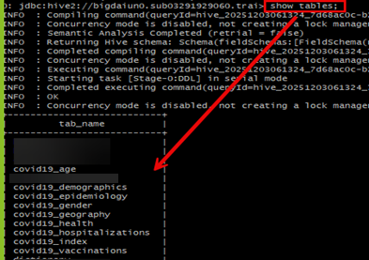

Next, paste the following HiveQL code to create a table called “covid19_aggregated,” which will join the data from the covid19 tables.
DROP TABLE IF EXISTS covid19_aggregated;

CREATE EXTERNAL TABLE IF NOT EXISTS covid19_aggregated(
event_date DATE,
location_key STRING,
country_code STRING,
country_name STRING,
subregion1_name STRING,
subregion2_name STRING,
new_confirmed INT,
cumulative_confirmed INT,
new_deceased INT,
cumulative_deceased INT,
new_recovered INT,
cumulative_recovered INT,
new_hospitalized_patients INT,
cumulative_hospitalized_patients INT,
new_intensive_care_patients INT,
cumulative_intensive_care_patients INT,
new_persons_fully_vaccinated INT,
cumulative_persons_fully_vaccinated INT,
adult_male_mortality_rate DOUBLE,
adult_female_mortality_rate DOUBLE,
life_expectancy DOUBLE,
diabetes_prevalence DOUBLE,
health_expenditure_usd DOUBLE,
out_of_pocket_health_expenditure_usd DOUBLE,
population INT,
population_male INT,
population_female INT,
population_age_00_09 INT,
population_age_10_19 INT,
population_age_20_29 INT,
population_age_30_39 INT,
population_age_40_49 INT,
population_age_50_59 INT,
population_age_60_69 INT,
population_age_70_79 INT,
population_age_80_and_older INT
latitude DOUBLE,
longitude DOUBLE,
new_deceased_male INT,
cumulative_deceased_male INT,
new_deceased_female INT,
cumulative_deceased_female INT,
new_recovered_male INT,
cumulative_recovered_male INT,
new_recovered_female INT,
cumulative_recovered_female INT
new_recovered_age_0-9 INT,
new_recovered_age_10-19 INT,
new_recovered_age_20-29 INT,
new_recovered_age_30-39 INT,
new_recovered_age_40-49 INT,
new_recovered_age_50-59 INT,
new_recovered_age_60-69 INT,
new_recovered_age_70-79 INT,
new_recovered_age_80-89 INT,
new_recovered_age_90-99 INT,
cumulative_recovered_age_0-9 INT,
cumulative_recovered_age_10-19 INT,
cumulative_recovered_age_20-29 INT,
cumulative_recovered_age_30-39 INT,
cumulative_recovered_age_40-49 INT,
cumulative_recovered_age_50-59 INT,
cumulative_recovered_age_60-69 INT,
cumulative_recovered_age_70-79 INT,
cumulative_recovered_age_80-89 INT,
cumulative_recovered_age_90-99 INT)
ROW FORMAT DELIMITED FIELDS TERMINATED BY ','
STORED AS TEXTFILE
LOCATION '/tmp/group3_covid19/aggregated';
Query the content of the covid19_aggregated table to ensure that the table has been created successfully.

SELECT * FROM borough_data LIMIT 3;

Check how many rows are in our covid19_aggregated table

SELECT COUNT(*) FROM covid19_aggregated;

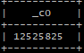

In the Hive shell CLI, paste the following HiveQL code to create an empty table called covid19_top10_countries, which will contain the cumulative confirmed cases for each country and its subregions (city & states) from covid19_aggregated tables once the data has been formatted.

